**Task 1:**

Host U can communicate with VPN Server.

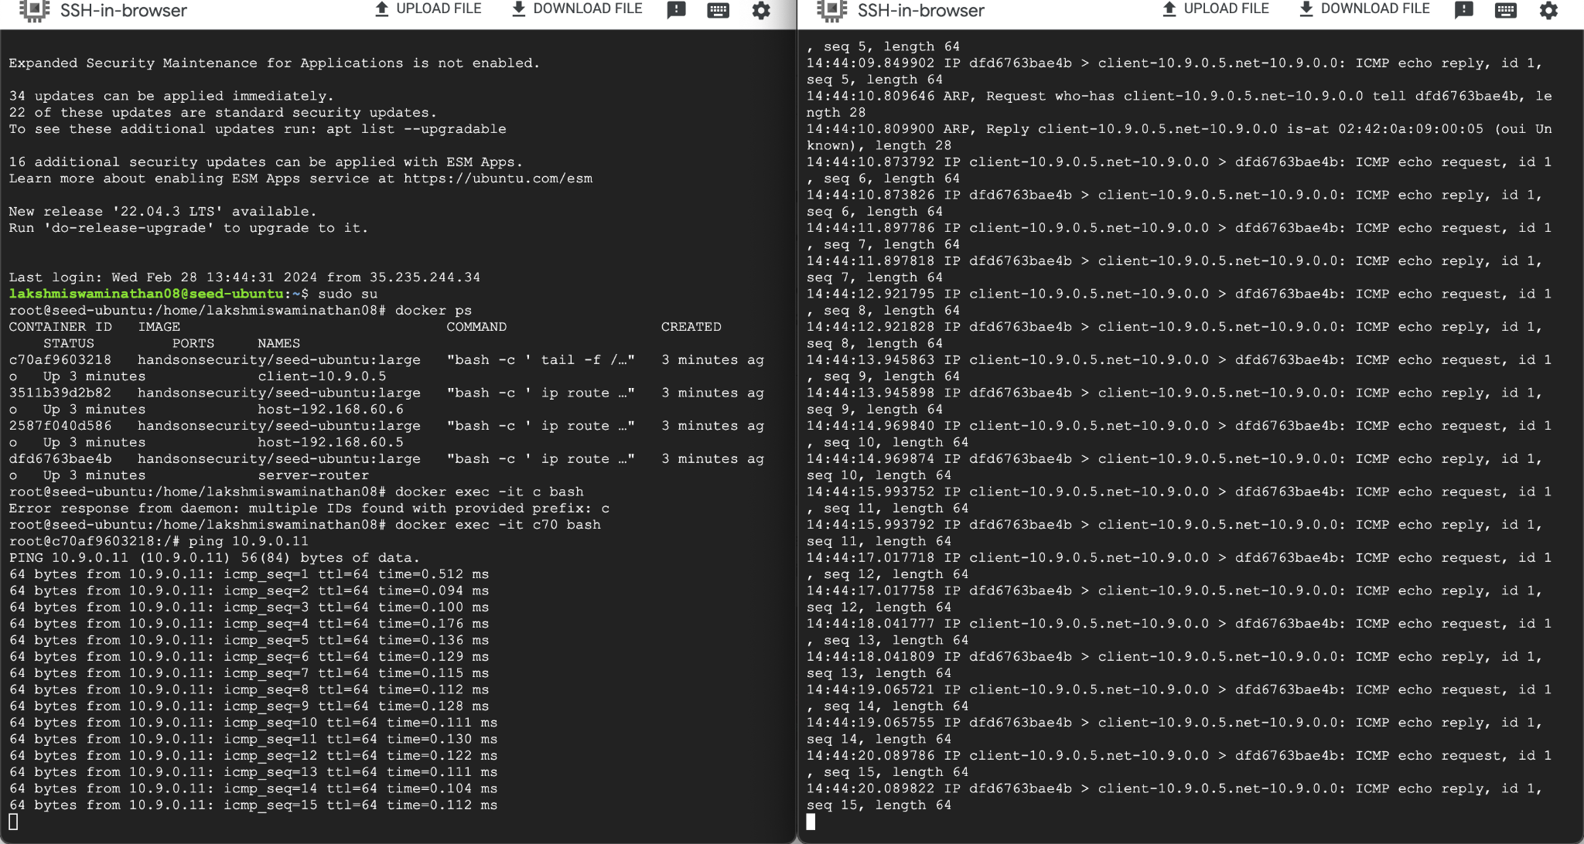

VPN Server can communicate with Host V.

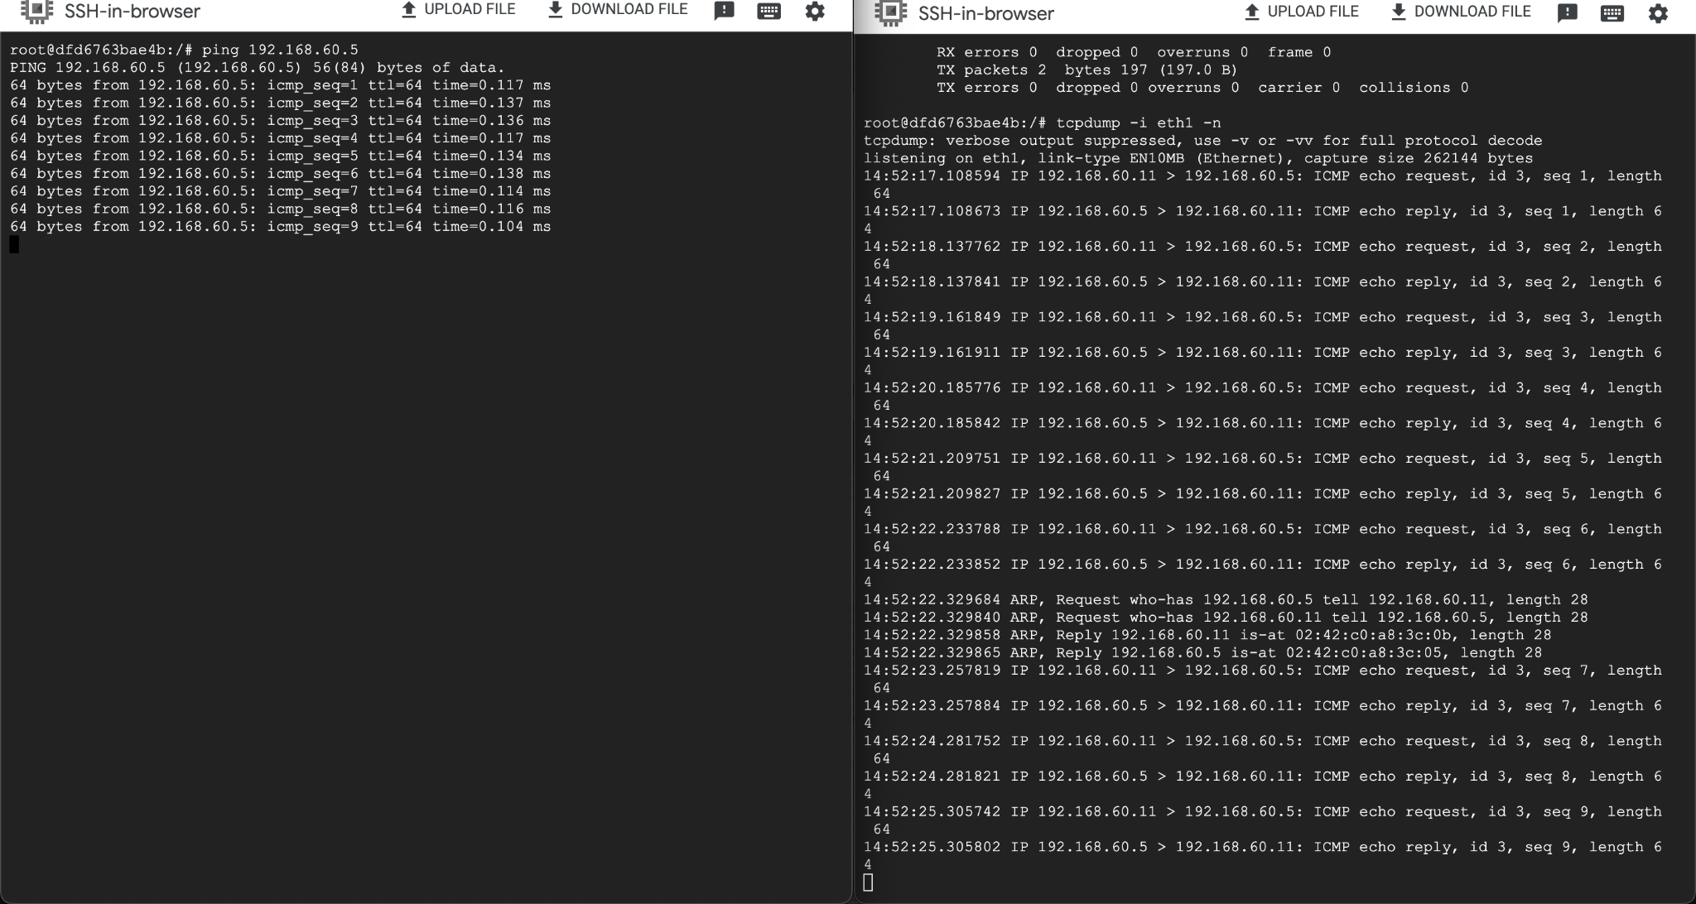

Host U is not able to communicate with Host V.

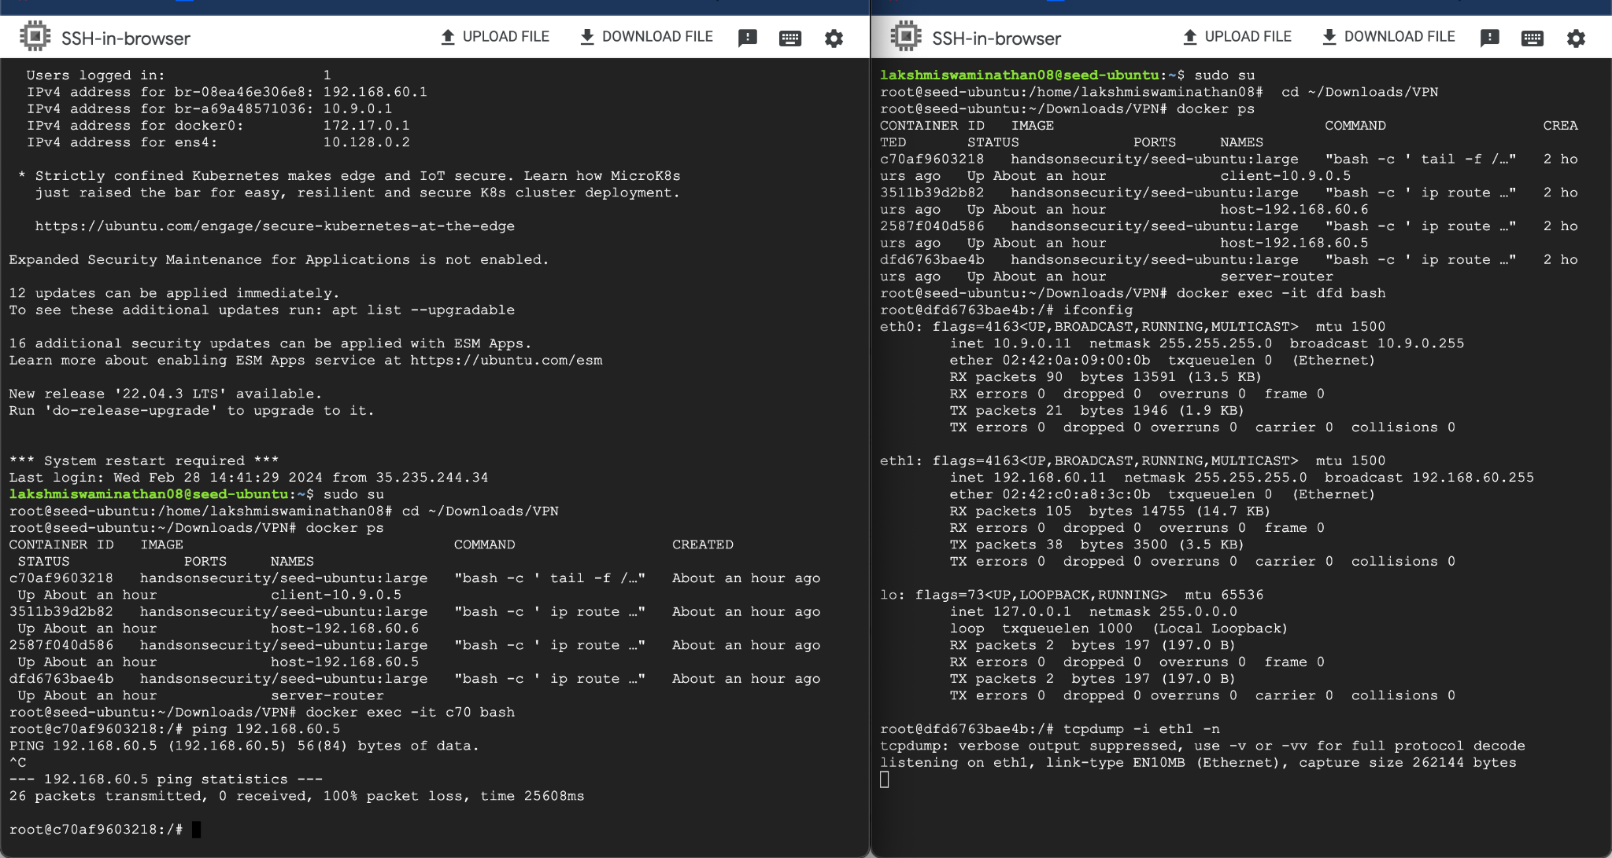

**Task 2: Create and Configure TUN Interface**

**Task 2.a: Name of the Interface**

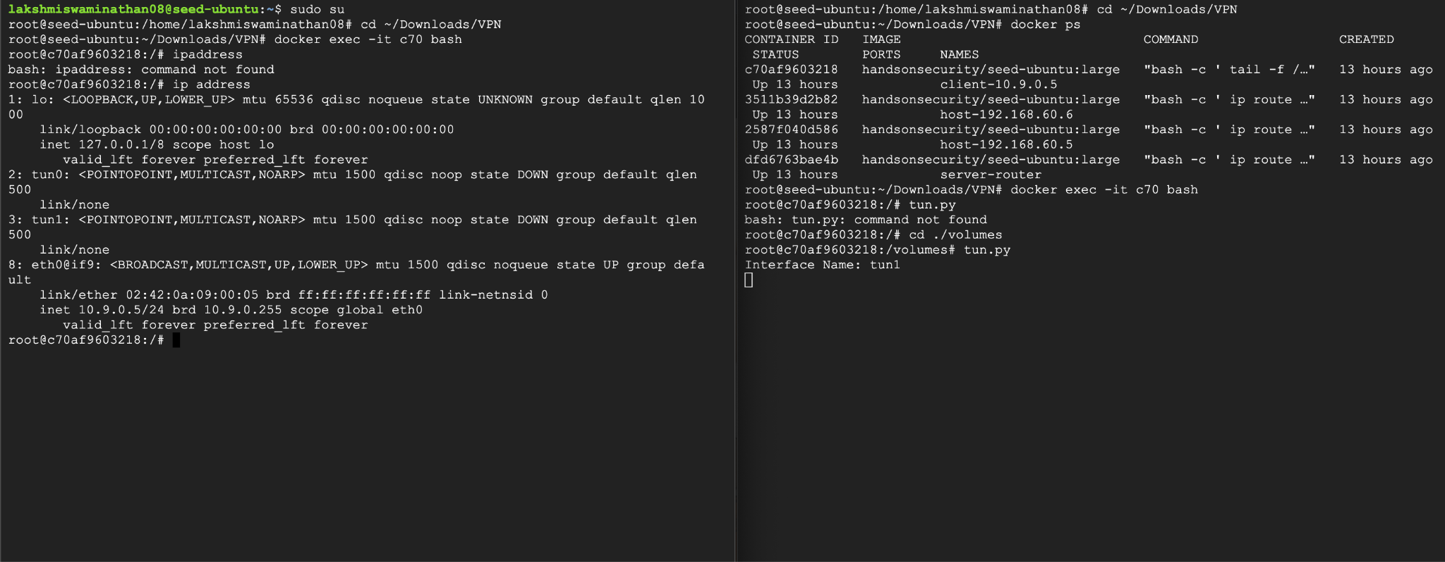

**Task 2.b: Set up the TUN Interface**

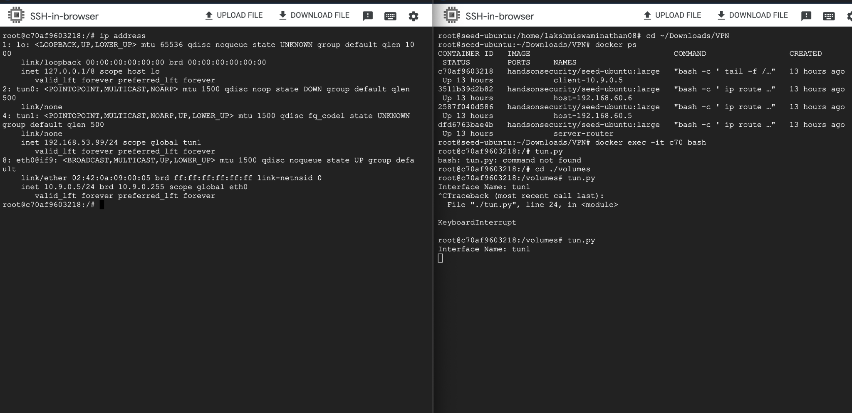

**Task 2.c: Read from the TUN Interface**

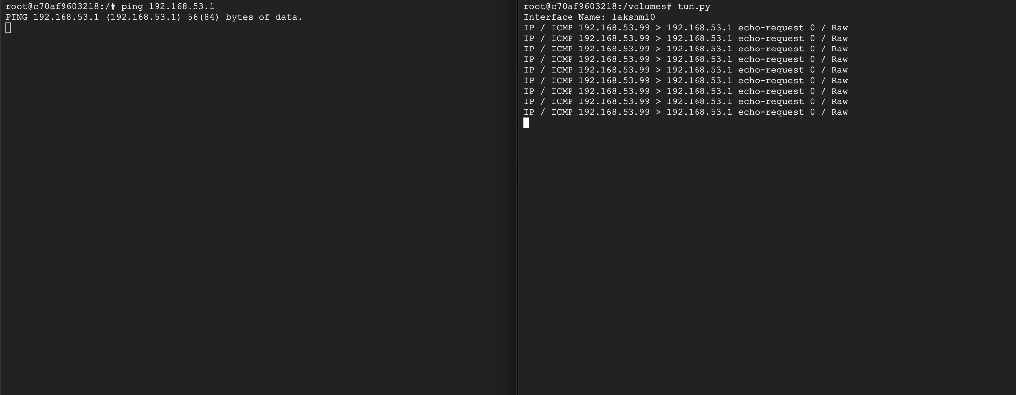



**Task 2.d: Write to the TUN Interface**

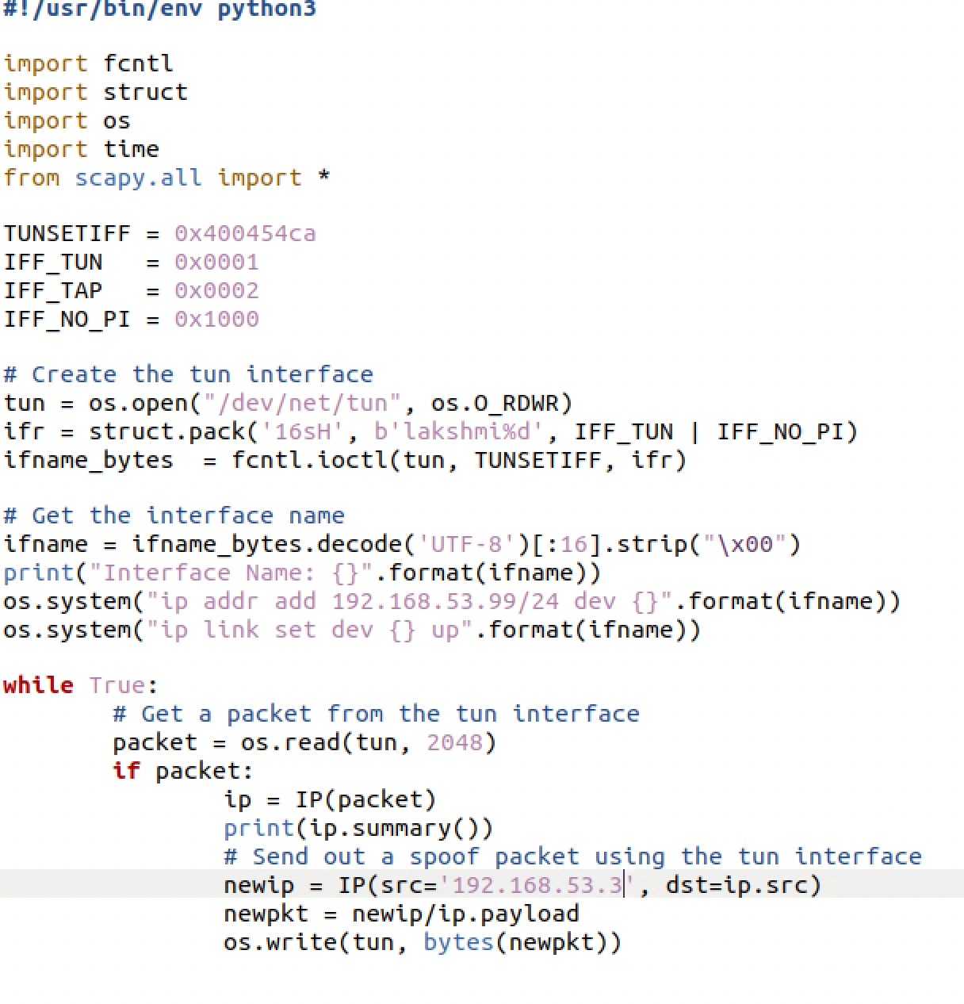

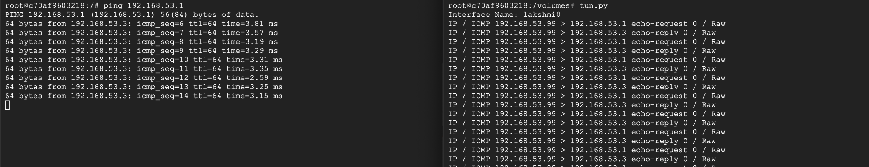

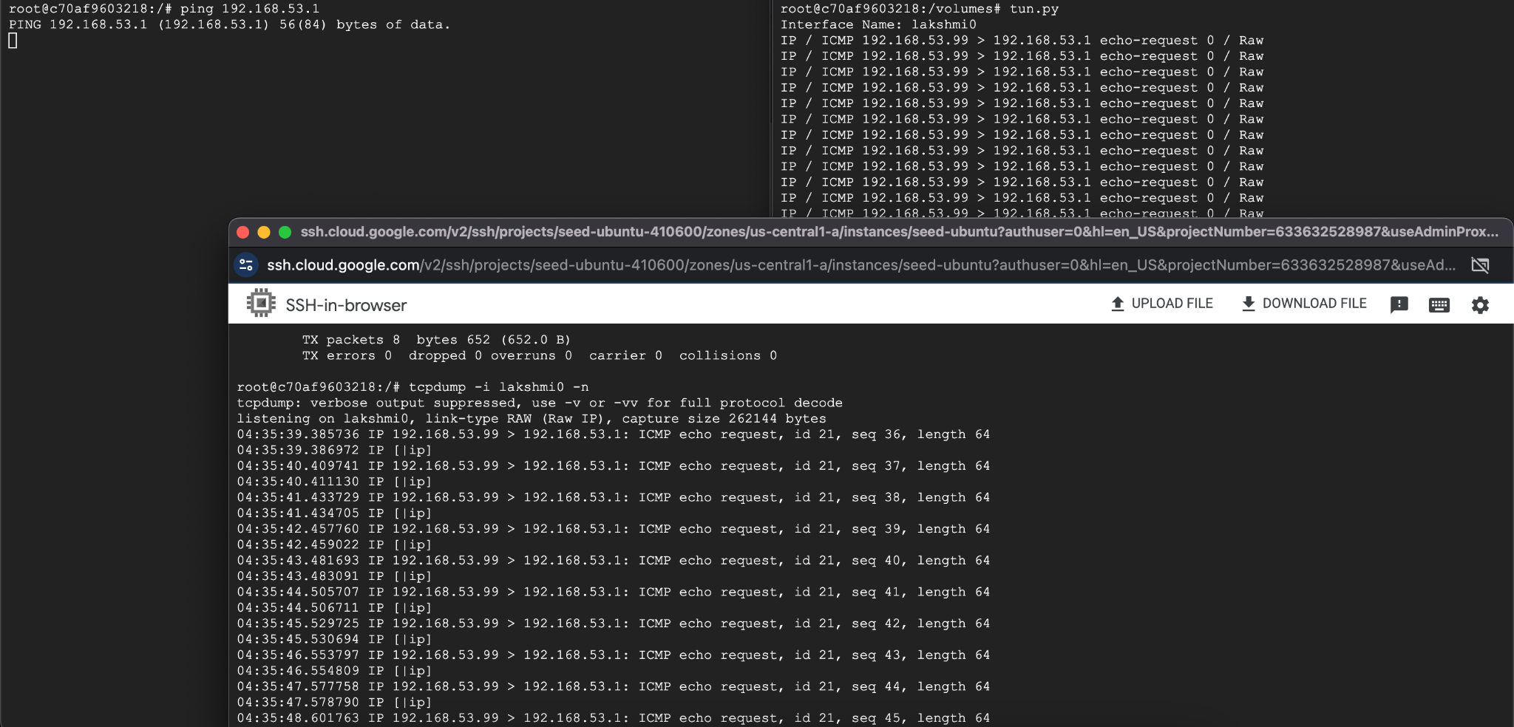

**Task 2 -Final code:**

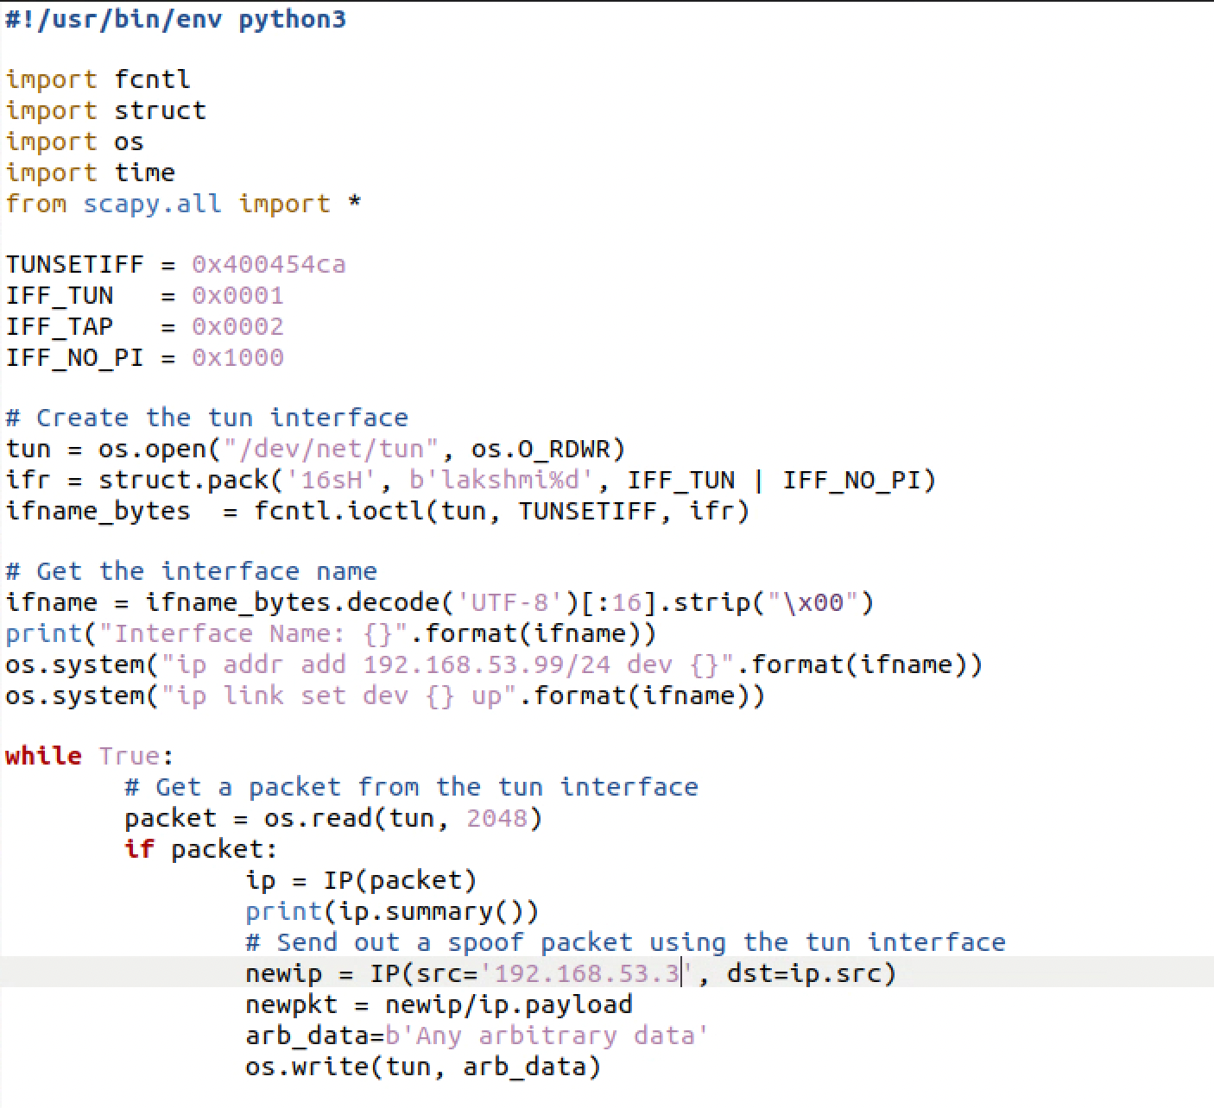

**Task 3: Send the IP Packet to VPN Server Through a Tunnel**

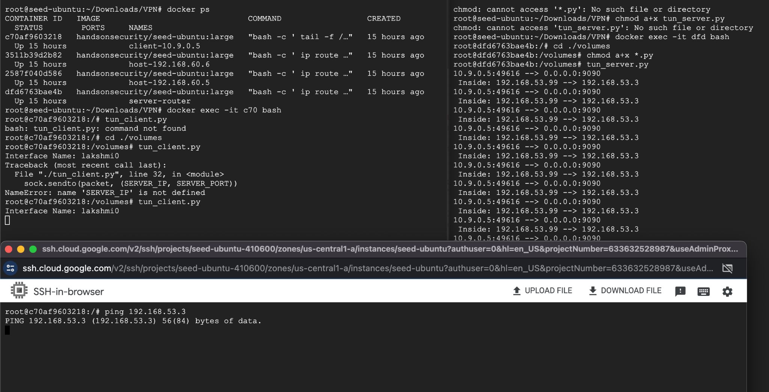

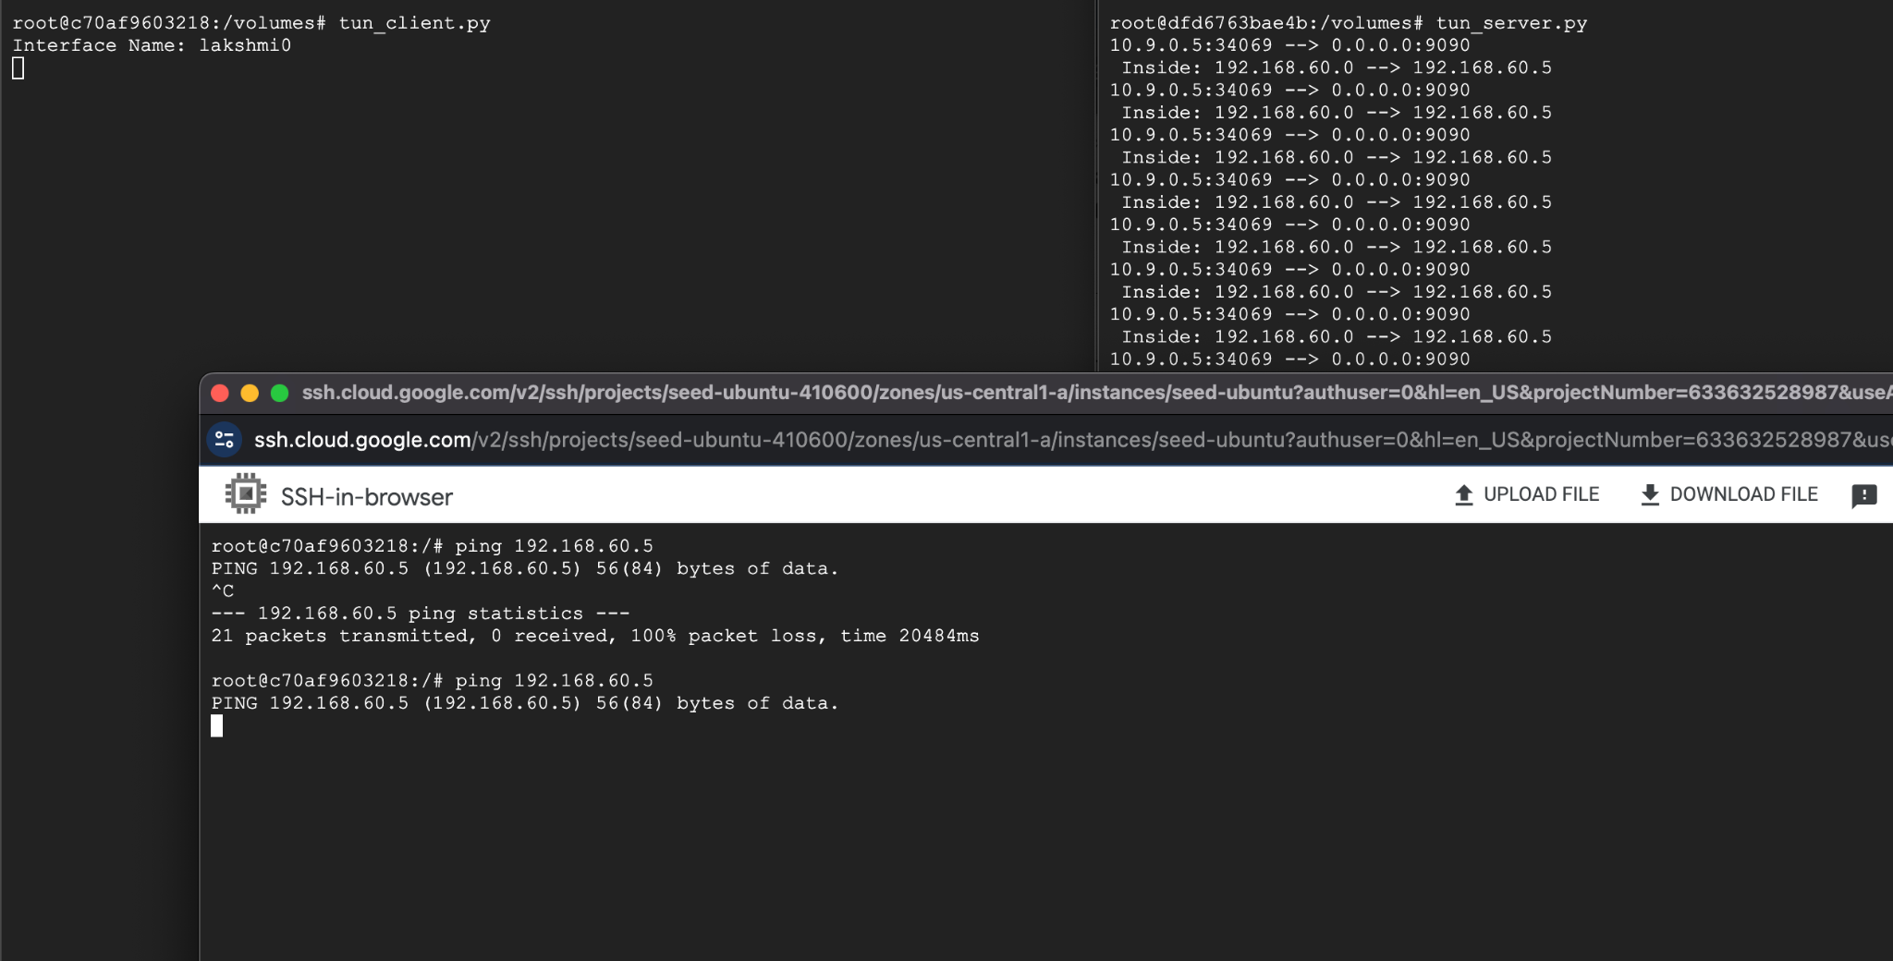

**tun_client code**

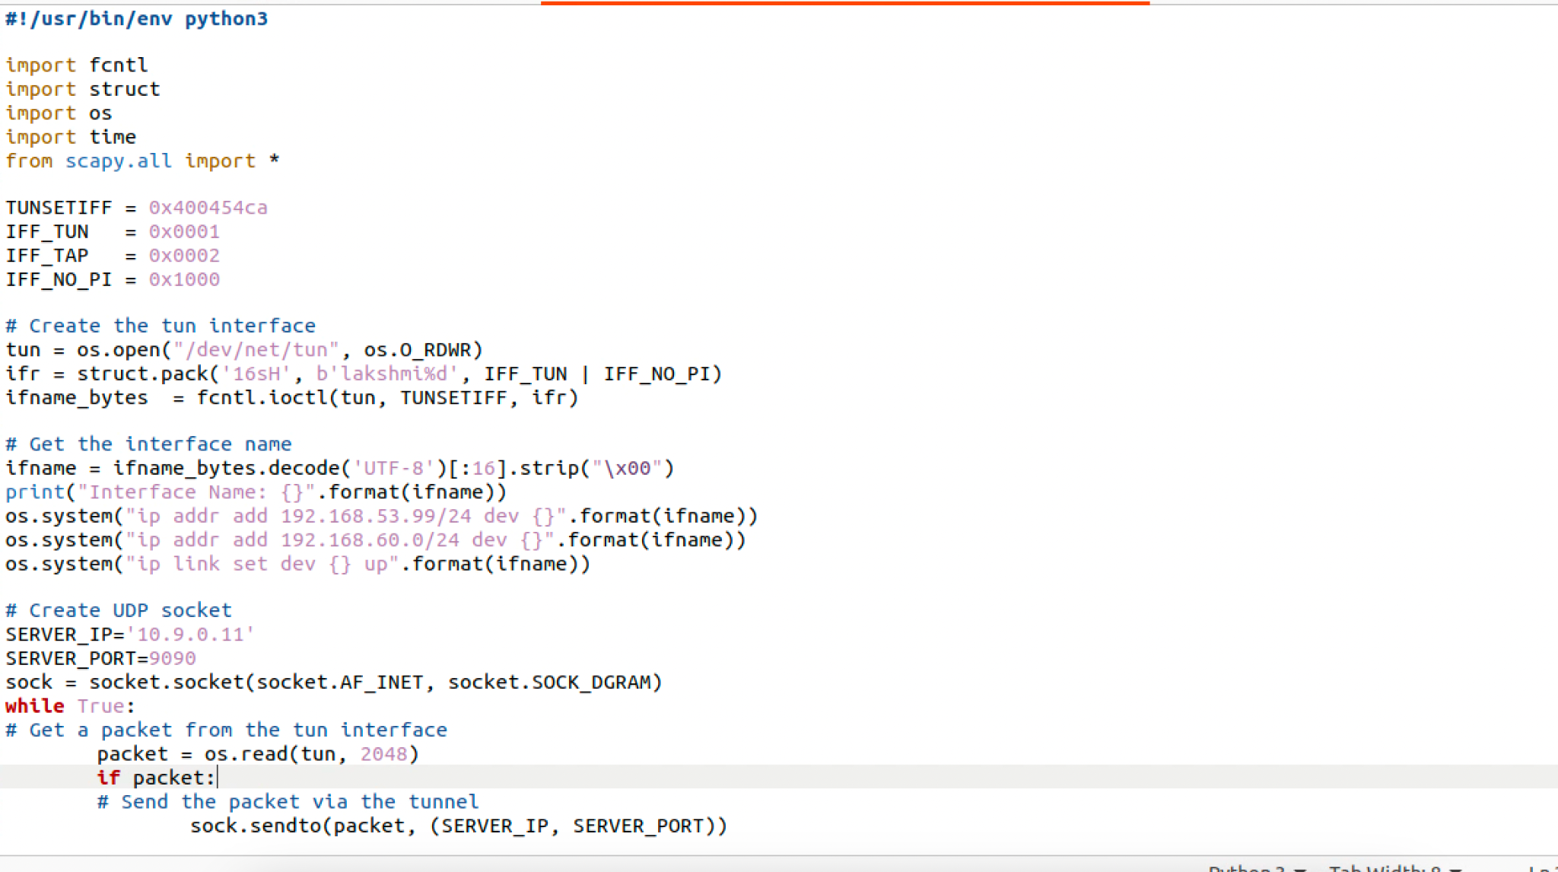

**tun_server code**

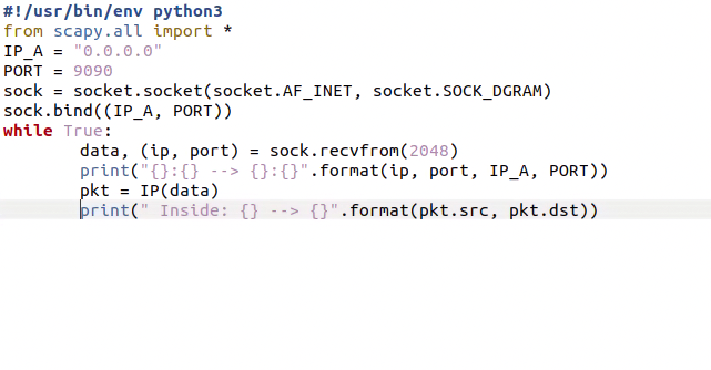

**Task 4: Set Up the VPN Server**

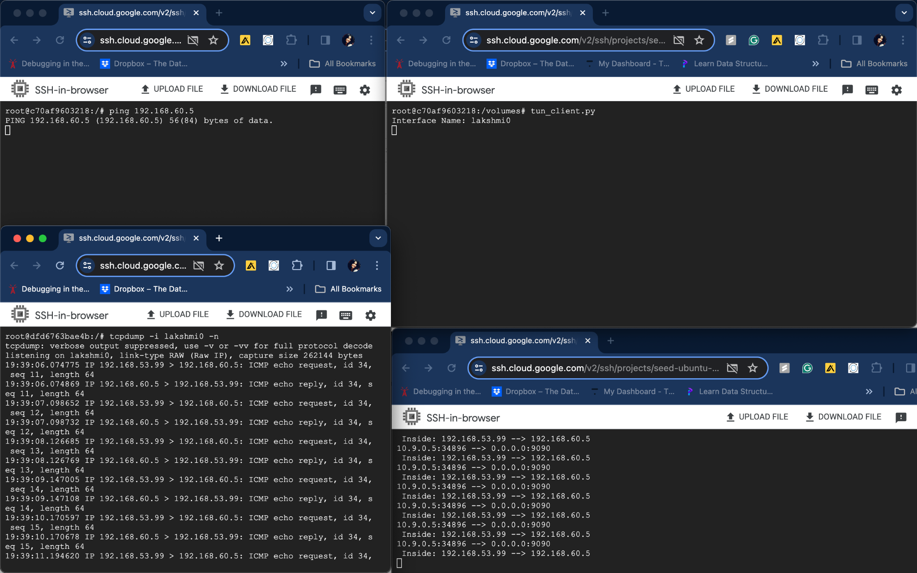

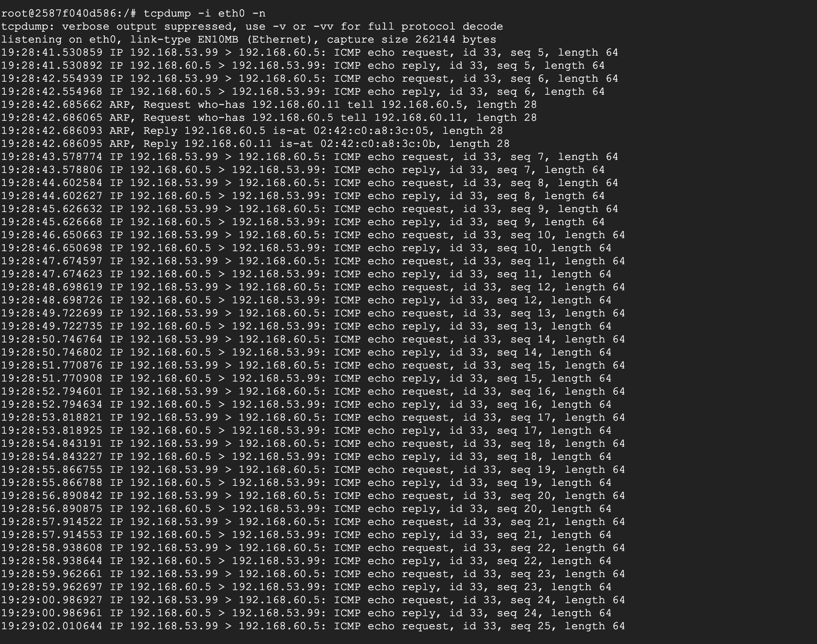

**tun_server code**

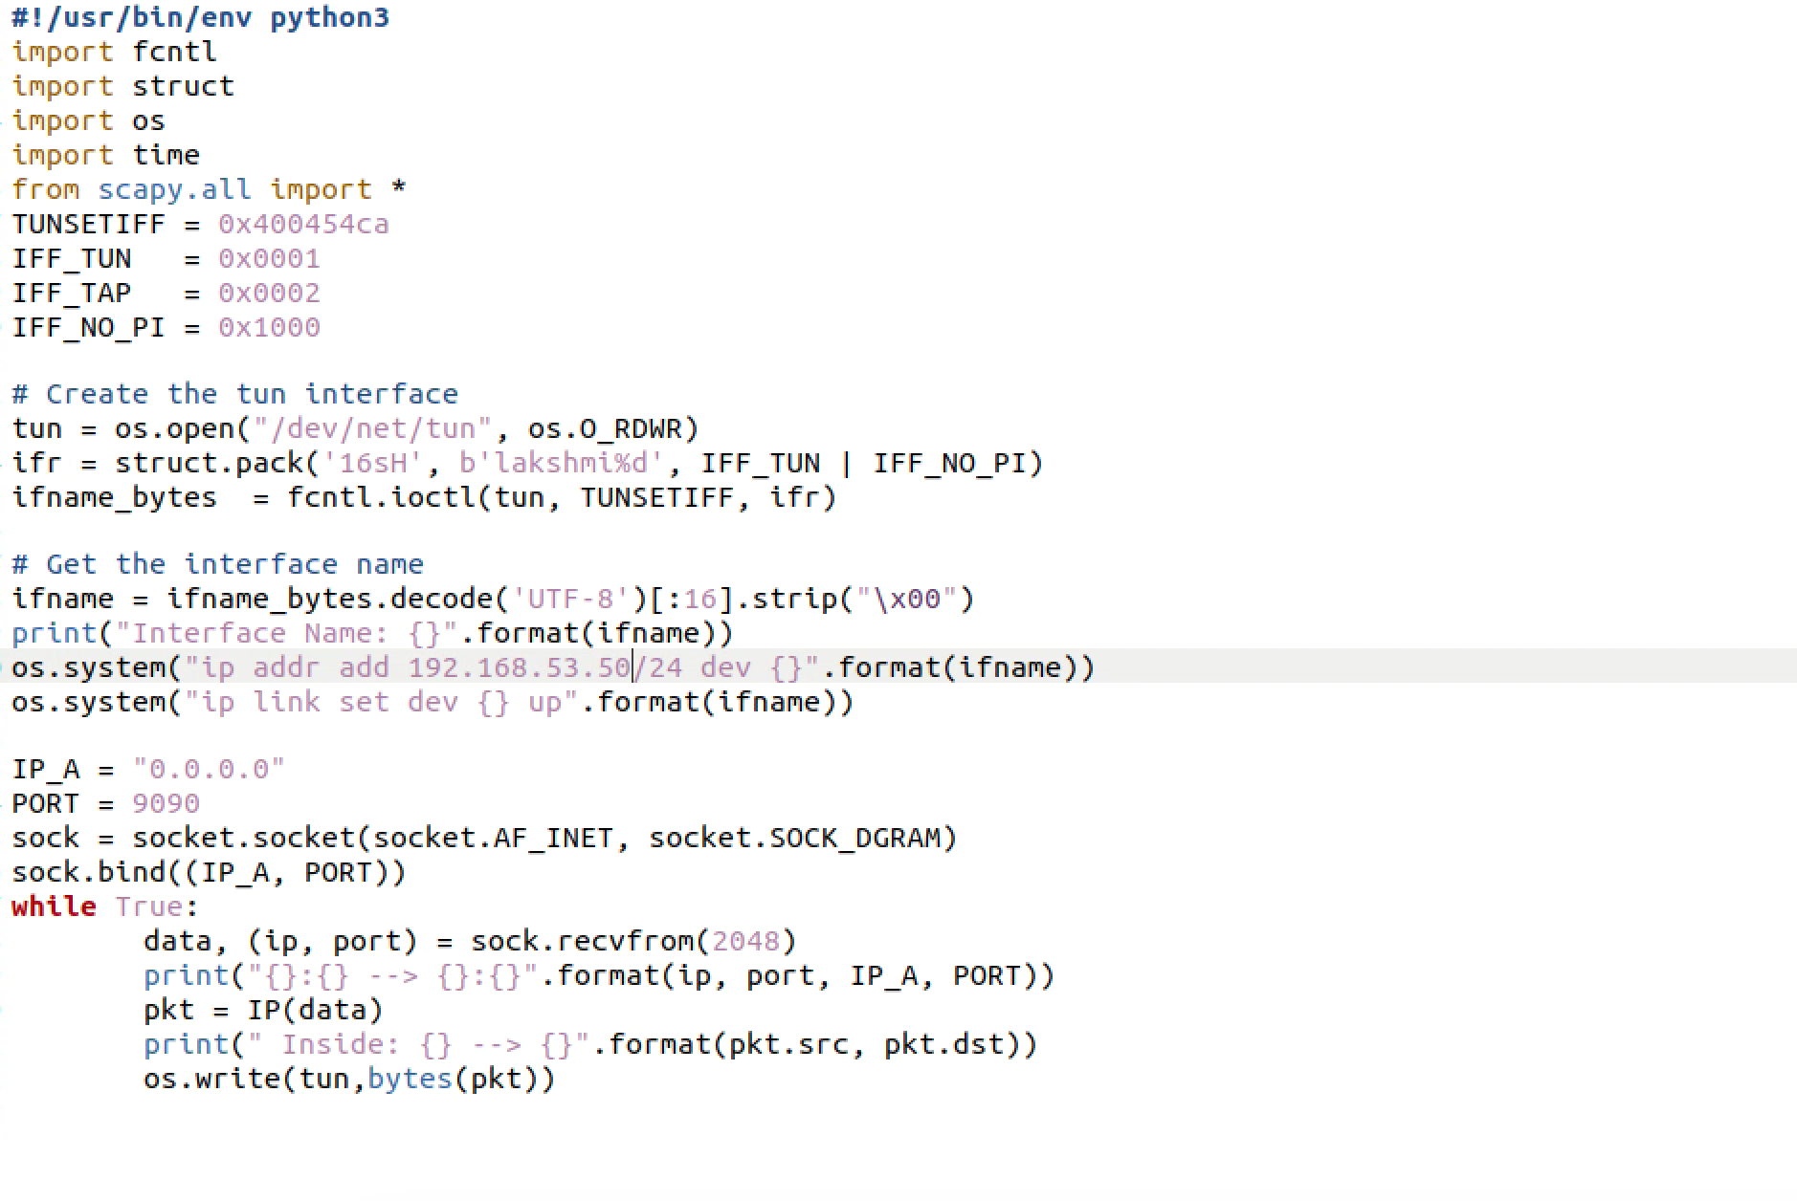

**Tun_client code**

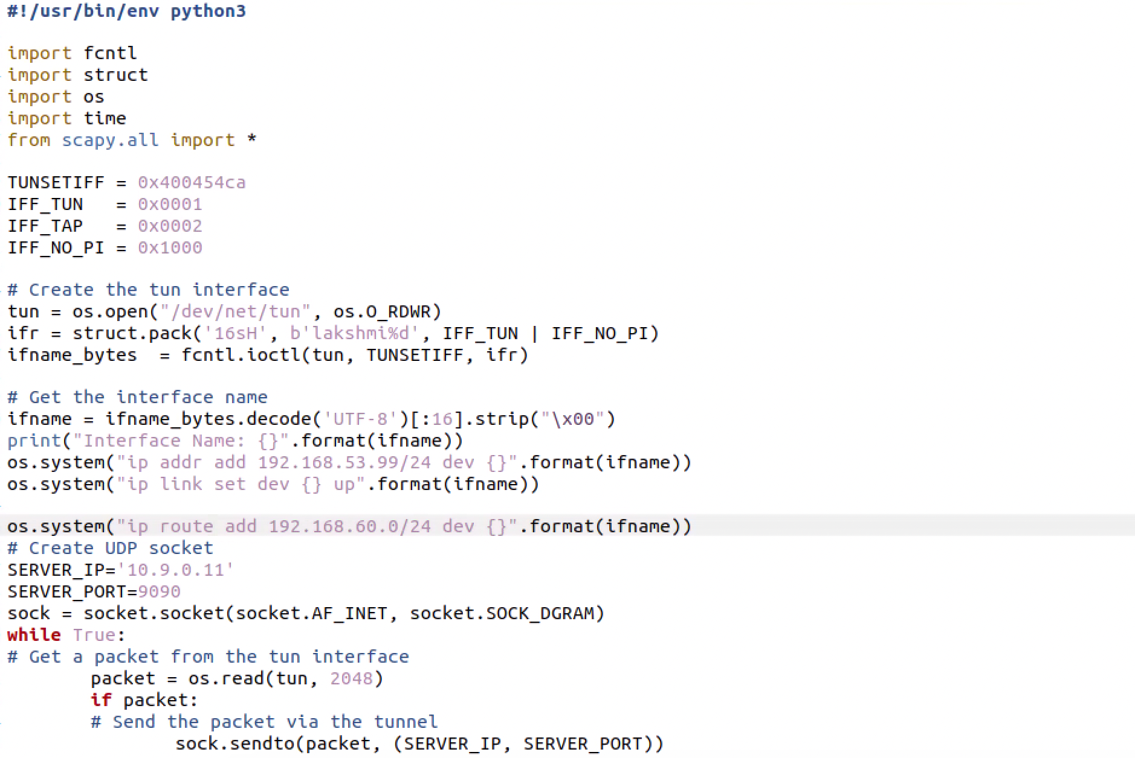

**Task 5: Handling Traffic in Both Directions**

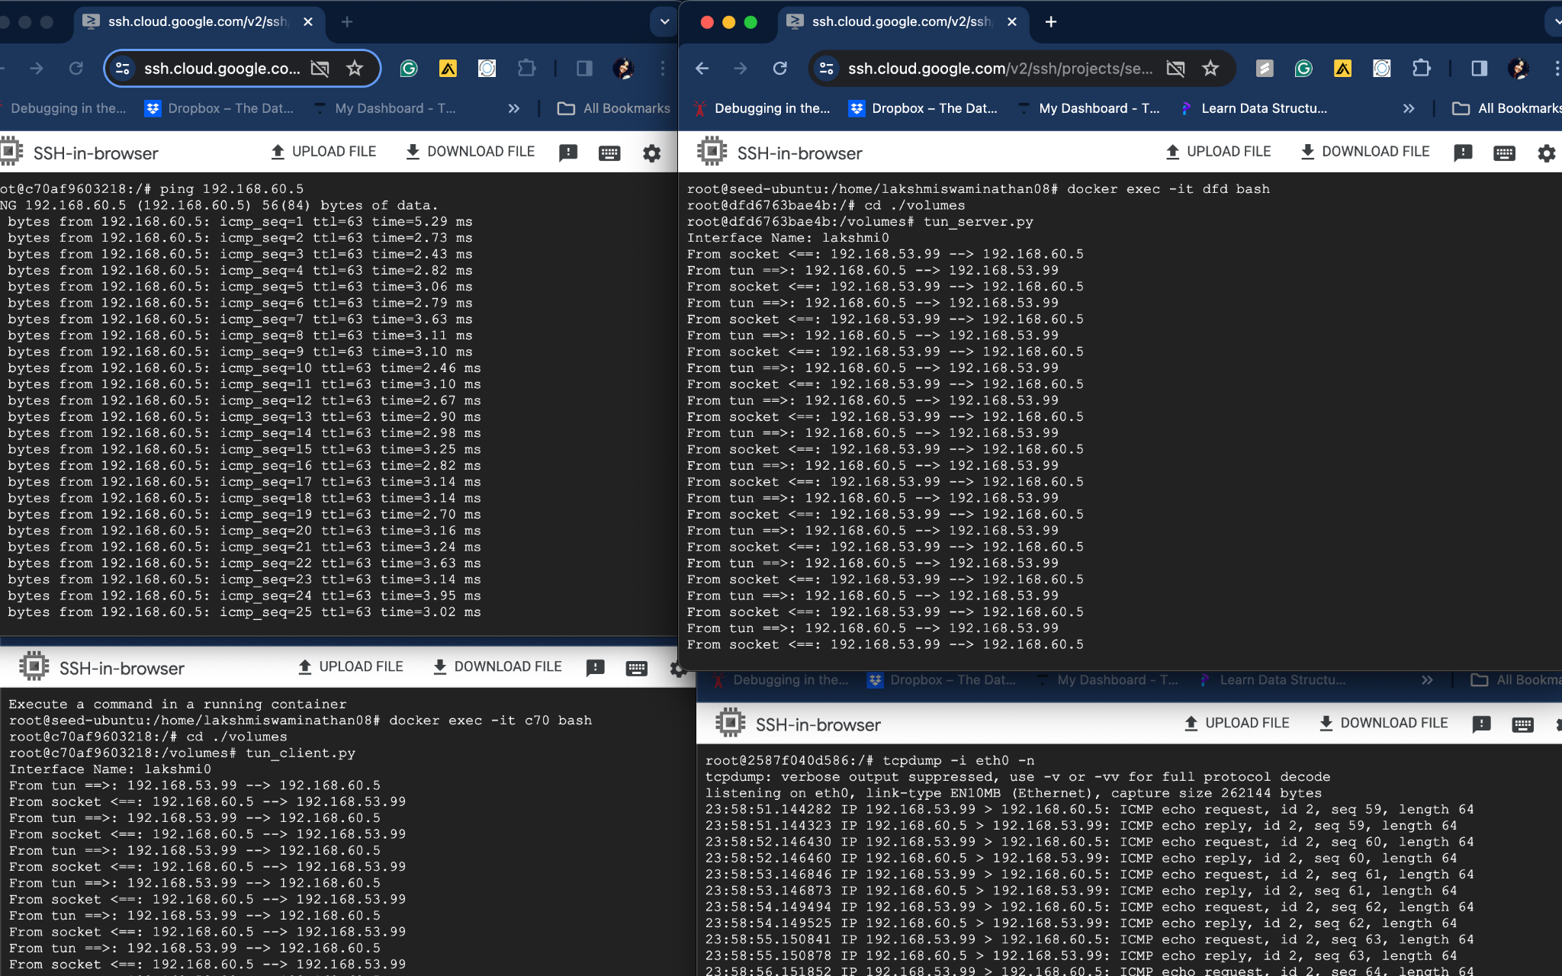

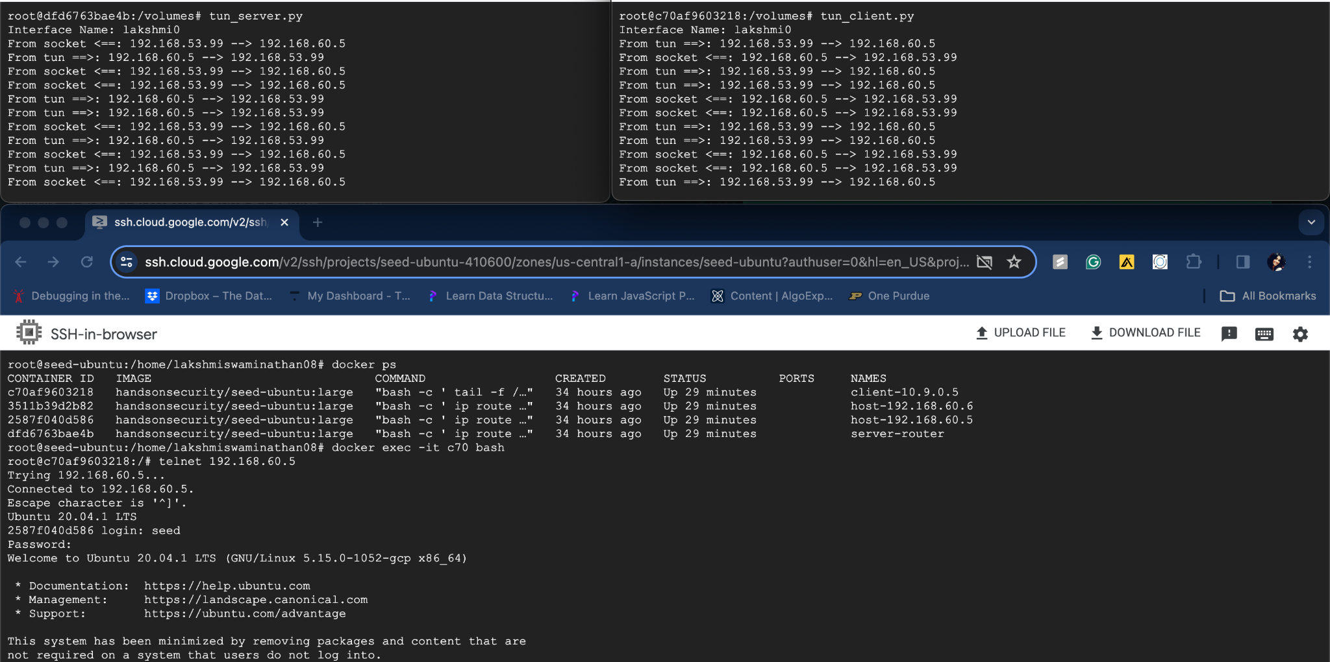

**Task 6: Tunnel-Breaking Experiment**

Telnet connection established between client and host within a private network(192.168.60.5)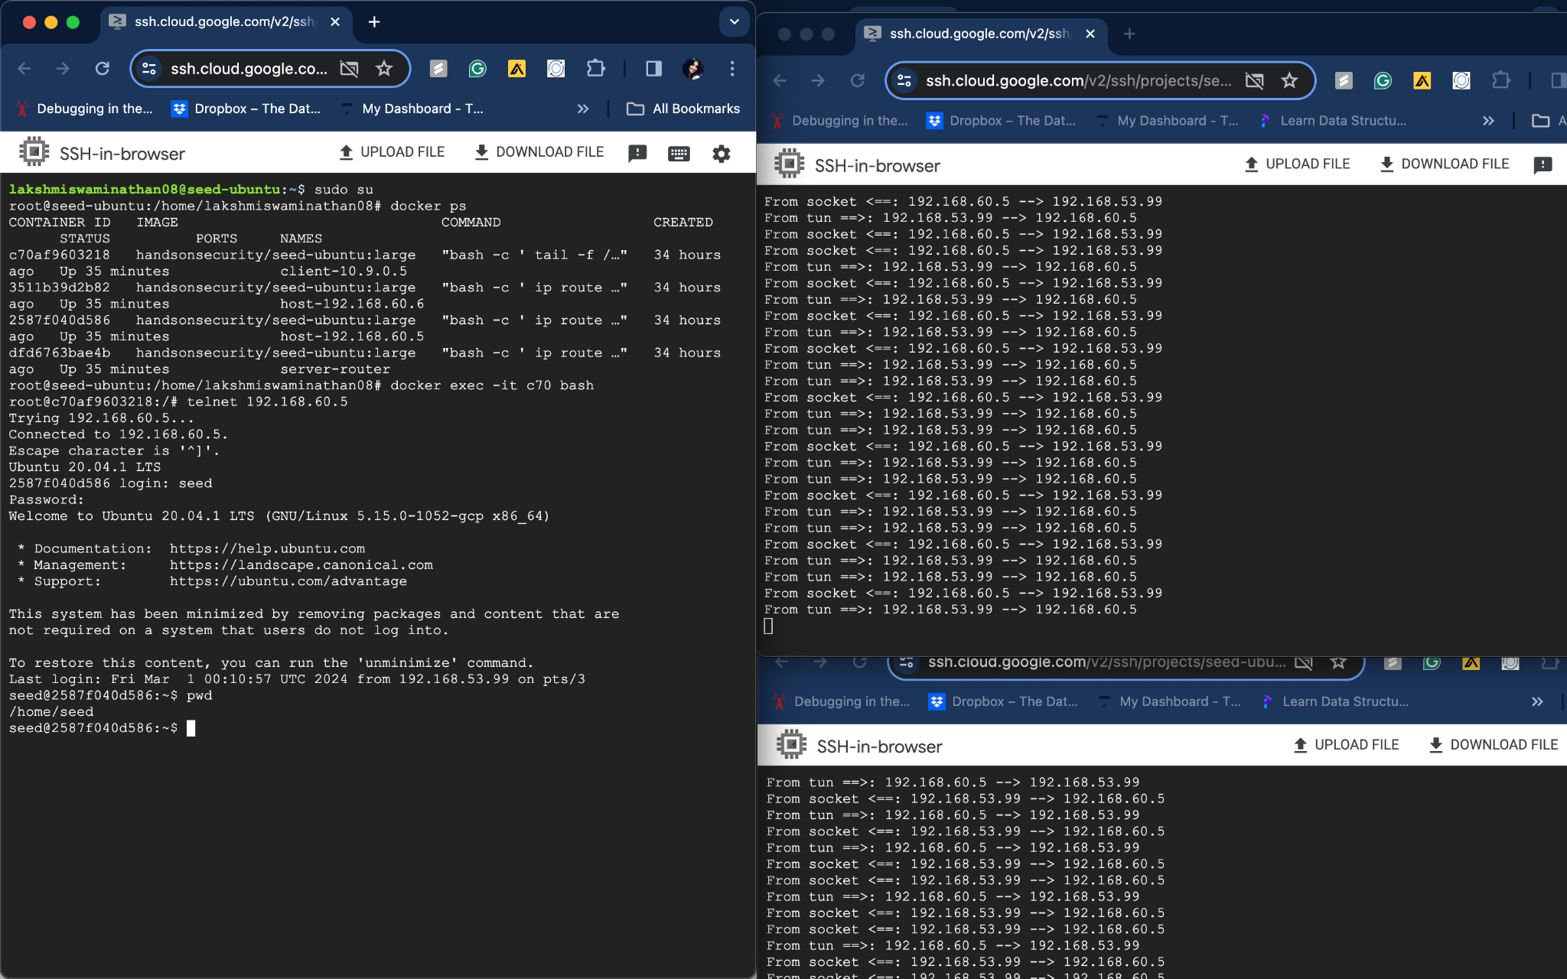

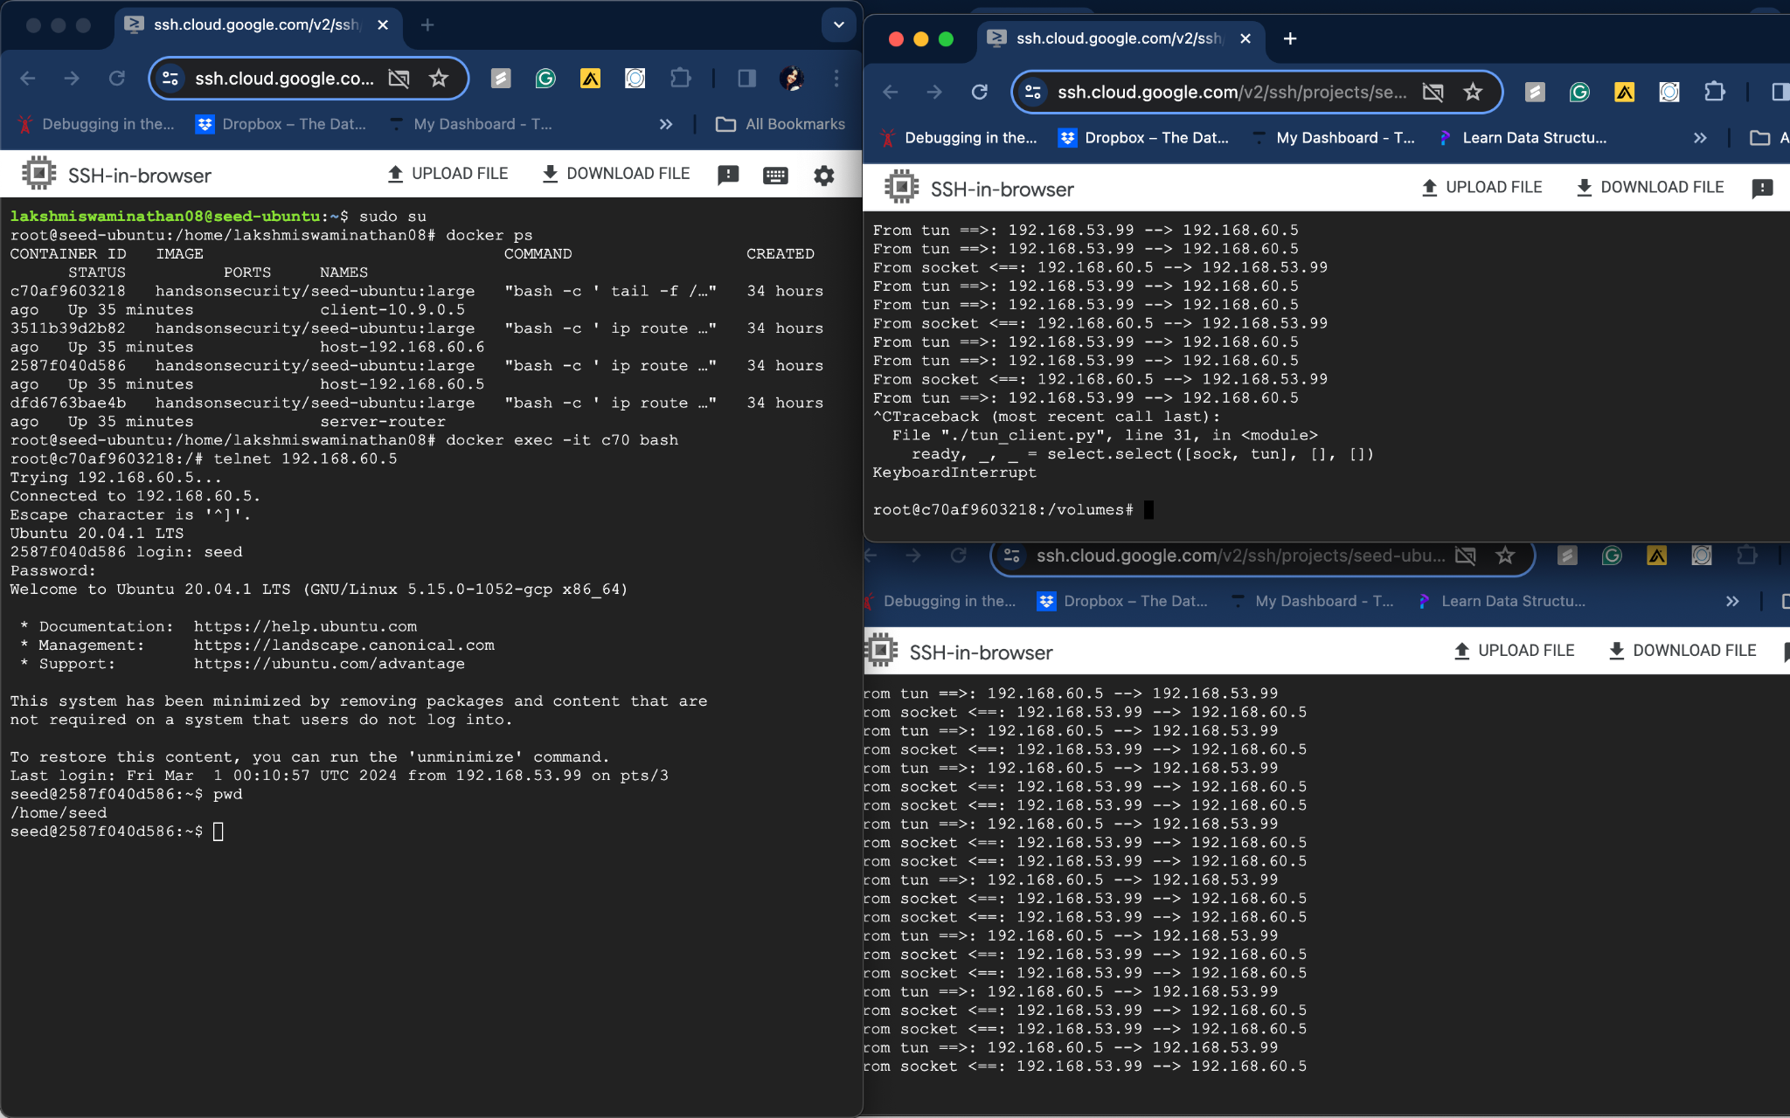

VPN Tunnel is broken by stopping tun_client/tun_server for a while and the telnet connection is frozen. Column’t type any cmds

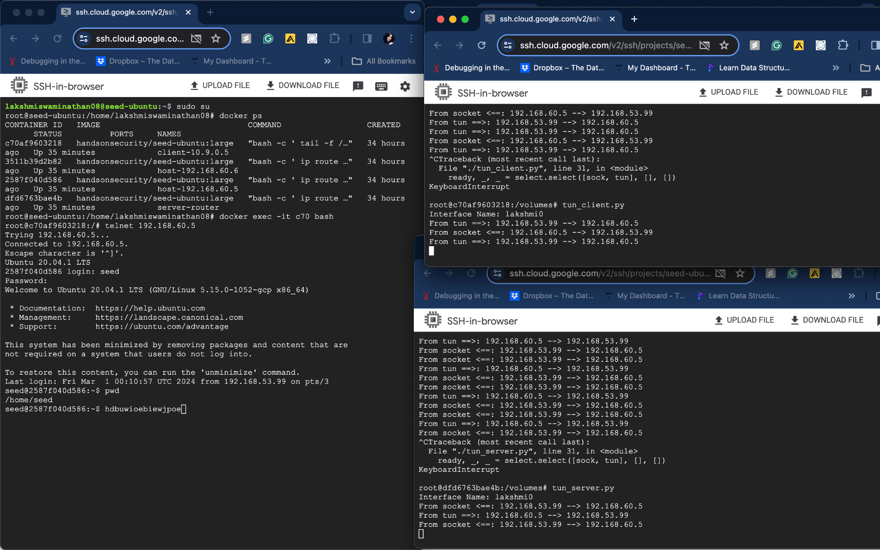

Once the connection is revived having the tunnel broken for a while, the text that was typed when the connection is broken is showing up.

**Task 7: Routing Experiment on Host V**

Default route for 192.168.60.5 is 192.168.60.11- Host u(client) is successfully able to ping host v.

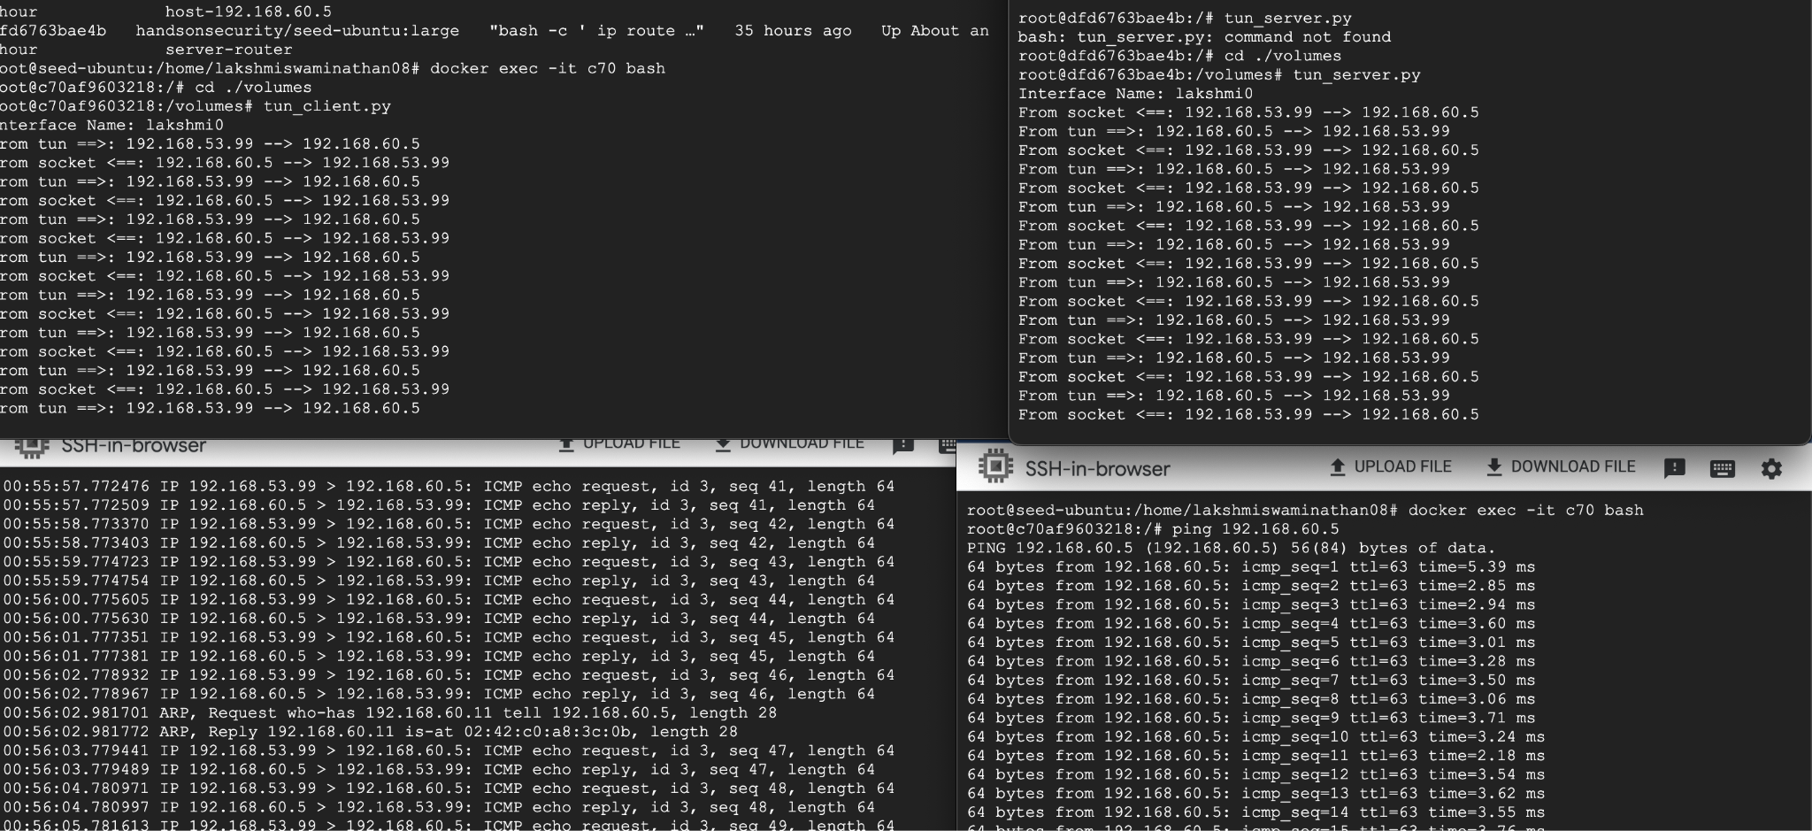

After deleting the default route, connection broke between client and hosts in private network

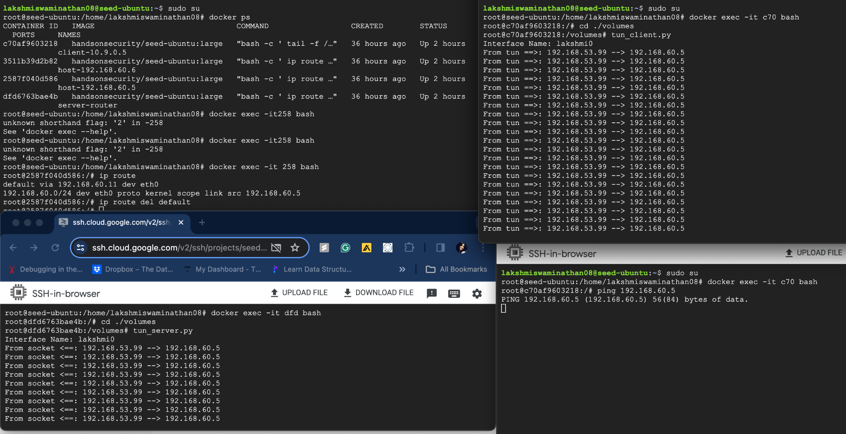

Connection between client and private network is preserved once the default route is added back.

